Web Mining - CSE3024
Slot – L33-L34
Faculty – Prof. Sridhar R
Dhrubanka Dutta
17BCE1019

Jgvkdgva
Web usage mining lab on 18th March 2019

Following is a set of web usage logs from an organization. Assume the following rules.

a. The time heuristic h1 for a session duration = 30 minutes.
b. The time heuristic h2 for the average duration for the user visit of a page = 1 minute.
c. Include a page in a session if the page that refers is in that session.
d. During a session, the IP address, browser and OS is the same.
You need to printout a table containing session number, IP address, session start time and session end time.

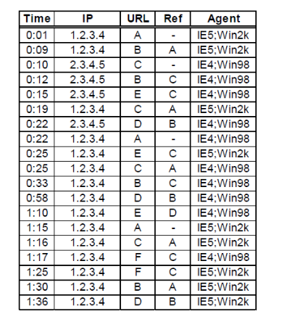

CODE:

time = ["0:01", "0:09","0:10","0:12", "0:15","0:19",
"0:22", "0:22","0:25","0:25", "0:33","0:58",
"1:10", "1:15","1:16","1:17", "1:25","1:30",
"1:36"]

ip = ["1.2.3.4","1.2.3.4","2.3.4.5","2.3.4.5","2.3.4.5",
"1.2.3.4","2.3.4.5","1.2.3.4","1.2.3.4","1.2.3.4",
"1.2.3.4","1.2.3.4","1.2.3.4","1.2.3.4","1.2.3.4",
"1.2.3.4","1.2.3.4","1.2.3.4","1.2.3.4"]

url = ['A','B','C','B','E','C','D','A','E','C','B','D','E','A','C','F','F','B','D']

ref = ['0','A','0','C','C','A','B','0','C','A','C','B','D','0','A','C','C','A','B']

agent = ["5:2K","5:2K","4:98","4:98","4:98","5:2K","4:98","4:98","5:2K","4:98","4:98","4:98",
"4:98","5:2K","5:2K","4:98","5:2K","5:2K","5:2K"]

mlis, check = [],[]

mlis.append(time)
mlis.append(ip)
mlis.append(url)
mlis.append(ref)
mlis.append(agent)

for i in range(len(mlis[0])):
check.append(0)
sl1 = int(mlis[0][i][0])
sl2 = int(mlis[0][i][2:4])
mlis[0][i] = sl1*60+sl2

ipset = list(set(ip))
agentset = list(set(agent))

mainlis = []
newvar = mlis[0][0] + mlis[0][len(mlis[0])-1]
interval = newvar-mlis[0][0]
toint = (interval//30)+1

for j in range(2):
for k in range(2):
lis = []
for i in range(len(mlis[1])):
if mlis[1][i] == ipset[j] and mlis[4][i]==agentset[k]:
lis.append(i)
mainlis.append(lis)

mainlis2 = []
lis = []

for x in range(2):
for i in mainlis:
for j in range(len(i)):
val = mlis[0][i[j]]
if mlis[3][i[j]]=='0':
mins = mlis[0][i[j]]
maxs = mins+30
if lis:
mainlis2.append(lis)
lis = []
if val>=mins and val<maxs:
lis.append(i[j])

mainlis2 = mainlis2[0:4]
finlis = []
lis = []
for i in mainlis2:
val = mlis[2][i[0]]
lis.append(val)
for j in range(1,len(i)):
lis.append(mlis[2][i[j]])
finlis.append(lis)
lis = []

count = 0
print("h1 heuristic along with h2 with the reference url's order is in below")
for i in mainlis2:
if i:
for j in i:
print(mlis[0][j],mlis[1][j],mlis[2][j],mlis[3][j],mlis[4][j])
print(finlis[count])
print("\n")
count=count+1

OUTPUT:

